Project Design Phase-II
Data Flow Diagram & User Stories

Date | 31 January 2026
Team ID | LTVIP2026TMIDS62122
Project Name | Startup Success Prediction System Using Machine Learning
Maximum Marks | 4 Marks

Data Flow Diagrams:
A Data Flow Diagram (DFD) is a traditional visual representation of the information flows within a system. A neat and clear DFD can depict the right amount of the system requirement graphically. It shows how data enters and leaves the system, what changes the information, and where data is stored.
Example: DFD Level 0 (Industry Standard)
Example: (Simplified)
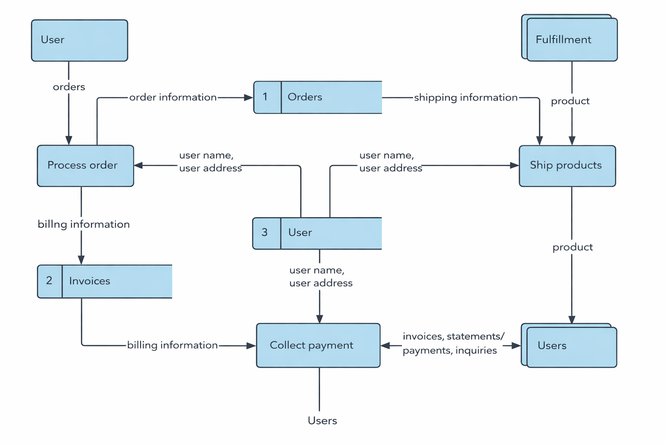
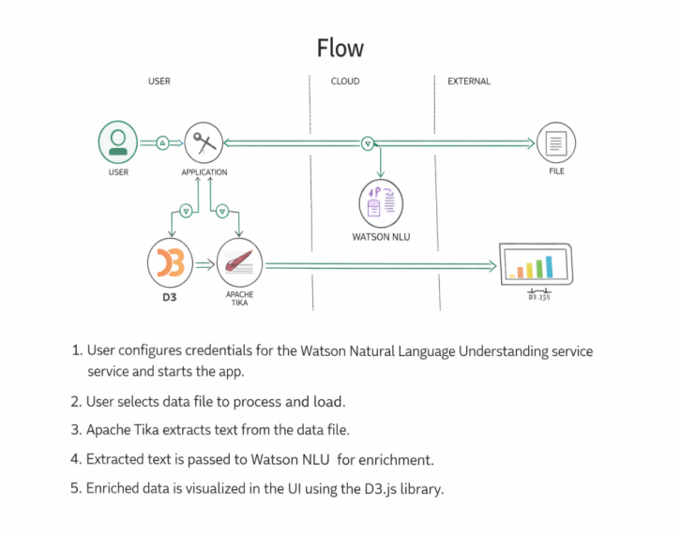
User Stories
Use the below template to list all the user stories for the product.
User Type | Functional Requirement (Epic) | User Story No. | User Story / Task | Acceptance Criteria | Priority | Release
Customer (Mobile User) | Registration | USN-1 | As a user, I can register by entering my email, password, and confirming my password. | User is redirected to dashboard after successful registration. | High | Sprint-1
 |  | USN-2 | As a user, I will receive a confirmation email after registration. | User receives email and can verify account by clicking confirmation link. | High | Sprint-1
 |  | USN-3 | As a user, I can register through Facebook. | User can login and access dashboard via Facebook authentication. | Low | Sprint-2
 |  | USN-4 | As a user, I can register through Gmail. | User can login and access dashboard via Gmail authentication. | Medium | Sprint-1
 | Login | USN-5 | As a user, I can log into the application using email and password. | User successfully logs in and accesses dashboard. | High | Sprint-1
 | Dashboard | USN-6 | As a user, I can view my personalized dashboard after login. | Dashboard displays user details and relevant features correctly. | High | Sprint-1
Customer (Web User) | Registration & Login | USN-7 | As a web user, I can register and login through the website. | User can access web dashboard after authentication. | High | Sprint-1
Customer Care Executive | Support Management | USN-8 | As a customer care executive, I can view and respond to customer queries. | Executive can update query status and respond to users. | Medium | Sprint-2
Administrator | User & System Management | USN-9 | As an admin, I can manage users and monitor system activities. | Admin can view, update, or deactivate users and generate reports. | High | Sprint-2
User Type | Functional Requirement (Epic) | User Story No. | User Story / Task | Acceptance Criteria | Priority | Release
Customer (Mobile User) | Registration | USN-1 | As a user, I can register by entering my email, password, and confirming my password. | User is redirected to dashboard after successful registration. | High | Sprint-1
 |  | USN-2 | As a user, I will receive a confirmation email after registration. | User receives email and can verify account by clicking confirmation link. | High | Sprint-1

